ElrNEWSLETTER JUNE 2011

ELVIS Race 1 - Havering 90 Midweek 5 Miles
East London Runners win individual and Team prizes
Tuesday 21st June 2011.
211 Finishers - 140 Men and 71 Ladies - Biggest Attendances - Dagenham 38, ELR 25, Havering 25, Barking 24, Ilford 16, Eton Manor 16, Orion 14. 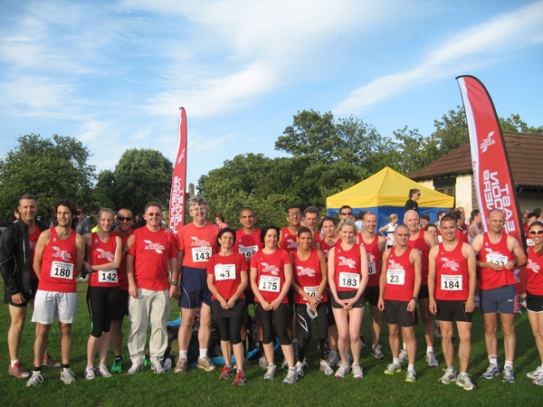
Some of the East London Team before the race started
Video Footage by "Carry On Running" available on YouTube here
Grant's report On a pleasant but windy mid summer's evening 28 members of East London Runners plus one supporter, Lance, met at Raphael Park Romford, the venue for the 1st ELVIS race of 7 this summer. With 25 runners, 1 injured Chairman who took the photos and cheered on the runners and two who were late and were unfortunately unable to run, one of whom for the second year running, perhaps it will be third time lucky next year! Conditions were more favourable than they were last year when the race was run in the middle of a heatwave. This was borne out by some excellent times posted by a number of the ELR contingent when compared to last year's efforts with a number of pb's. The quiet Irishman, Brendan O'Grady was first through the park gates after 200 metres and smashed the field to record an incredible time of 27.28 to take first prize with ease and collected his trophy in front of his cheering clubmates and proud Captains. Once again Karen was amongst the prizes taking the first Lady Vet prize and improving on her time by last year by 1 second! Ciaran was over 3 minutes faster than last year to claim 7th place ,with 4 other gents scoring for ELR , Manjit Bedi, Patrick Brown, Danny Lee and Andrew Baxter. Conveniently 3 of the first six men were vets so our first six men home satisfied the ELVIS rules and put the men into the lead in the series for the first time ever. Our ladies scoring team was completed by Ava Lee, Sharon Springfield and Helen Ringham to establish a narrow lead in the ladies competition going in to race 2 at Eton Manor on 10th July. Thanks are due also to our non-scoring runners for doing an excellent job for the Club on Tuesday e.g Andrea Waller our fifth lady home didn't score for the Club but by beating the 4th Eton Manor Lady athlete to the line by 2 seconds she lowered Eton Manors score and increased the ELR Ladies Team lead in the competition. Well done Andrea! 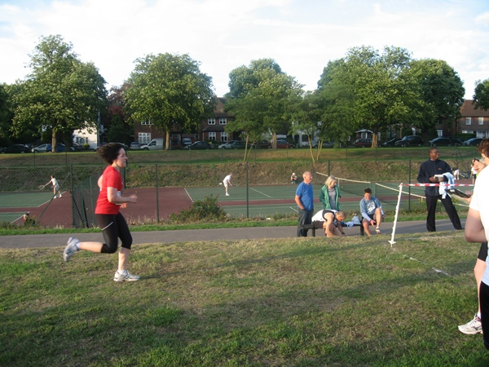
Andrea about to cross the finish line!
Of course Andrea's excellent run also affected every other Club's results as she beat well over half the Lady athletes in the field and affected their teams scores etc etc. The same applies for ALL our non-scoring runners so a massive well done and thank you for running and giving your best for the Club.
I can only plead once again for as many ELR runners as possible to turn out on 10th July for the Eton Manor 5k and in the rest of the series to help the club do as well as possible. If you are able to complete 5 races you will have the added bonus of qualifying for the individual championship in your category ! Go ELR!
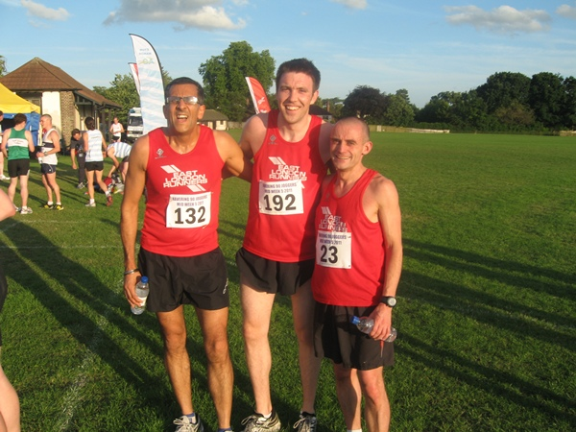
Manjit Bedi,Brendan and Ciaran after the race
Brendan O'Grady | 27:28 | 1st
Ciaran Canavan | 29:01 | 7th
Manjit Bedi | 30:39 | 22nd
Patrick Brown | 31:04 | 26th
Danny Lee | 31:07 | 27th
Andrew Baxter | 31:26 | 33rd
Manjit Singh | 31:51 | 37th
James Wilson | 32:38 | 44th
Karen Levison | 33:06 | 50th
Derek Wright | 33:29 | 52nd
Ava Lee | 34:29 | 65th
Sharon Springfield | 34:36 | 67th
Grant Conway | 35:12 | 75th
Paul Thompson | 36:21 | 87th
Carlton D'Souza | 36:33 | 90th
Helen Ringham | 36:47 | 93rd
Patrick Farren | 37:11 | 98th
Andrea Waller | 38:46 | 108th
Rachel Coombs | 40:49 | 128th
Katherine Jones | 41:50 | 137th
Michael Rose | 43:06 | 149th
Louisa Tock | 43:43 | 154th
Roger Dixon | 44:51 | 167th
Jayne Brown | 45:02 | 168th
Don Bennett | 46:27 | 179th

ELVIS GRAND PRIX SERIES - Summer 2011
East London 5's Interclub Series - Remaining Race Dates!
Message to all East London Runners from ELR Elvis Captains Karen Levison and Grant Conway!
ELVIS 2011 your Club still needs you !
The first ELVIS race has been run with Brendan winning the overall race and Karen 2nd lady and first Lady Vet. Both the Ladies and Mens teams won the team trophies. Great results for our Club.
The second race is the Eton Manor 5k on Sunday 10th July 2011. It doesn’t matter how fast you are, your support for the event will be greatly appreciated.
For those of you who are new to the club this is our second year as a full member of the ELVIS series. Last year we came second to Ilford in both the male and female sections and with our strength in depth this year in both genders there is no reason why we cant go one better this year. The series is not all about the competition but is also an opportunity for Club members to socialise, cheer each other on and enjoy a relaxing drink after races and get to know each other better. The races are only 5k or 5 miles, so only a couple of hours or so of your time is required. We hope to see more of you at the remaining races!
The competing Clubs are East London Runners, Ilford AC, Orion Harriers, Barking Road Runners, Dagenham 88, Havering 90 and Eton Manor. Both individual and team prizes apply.
Race Dates and Times.
2. Sunday 10th July 2011 - Eton Manor 5k - Race H/Q is Waterworks Building, Le abridge Road, London E10 for run on footpaths on Leyton and Hackney Marshes.
wwww.eton-manor.com
3. Wednesday 20th July 2011 – Newman Hilly 5 – 7.30pm – Entries via ELR as subsidy given by Club for ELR Members
www.ilfordathleticclub.co.uk
4. Saturday 6th August 2010 – Orion 5 mile 10am – A continuous lap on good trails within Epping Forest.
www.orionharriers.org.uk
5. Bank Holiday Monday 29th August 2010 – Barking 5k - New Venue to be advised!
www.barkingroadrunners.org.uk
6. Sunday 11th September 2011 – Dagenham 88 5 mile’sh – 11am – Off Road - Eastbrook End Country Park
www.dagenham88runners.com
7. Sunday 25th September 2011 - Valentines Park 5k – 10am – 2 lap race on the footpaths within Valentines Park, Ilford.
www.eastlondonrunners.org.uk
Blade Feathers
East London Runners purchase two Blade Feathers
The ELR Committee recently discussed, researched and agreed to buy two Blade Feathers/Wind Sails. Ciaran Canavan took this project on board and took delivery, on behalf of the Club, of the Blades recently.
Their first use was at the ELVIS Race 1 in Raphael P ark, Romford where Ciaran put them together and they became a focal meeting point for the club members running that evening.
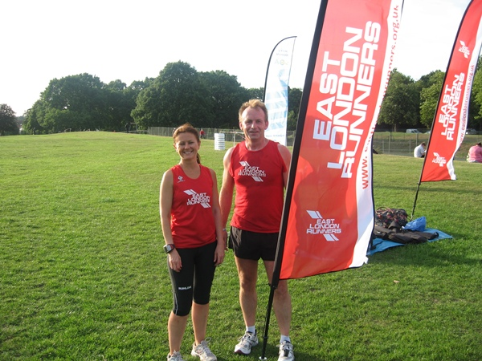
Tricia O'Neill and Jimmy Hartwell with the new blade feathers
Chingford League and Sunday Cross Country League
East London Runners has joined the Chingford League!
At a meeting of the full Management Committee of the Club on Wednesday 1st June 2011 it was agreed that we apply for membership to the Chingford League. The Chingford Leagu e have advised that they are happy to accept us.
Chingford League Fixtures 2011/2012.
The fixture dates have been largely sorted but the venues have not.
Tues 4 Oct 2011 - 8pm - 5k race at Redbridge Cycle Circuit
Sat 15 Oct 2011 - 2.30pm -5m race at Trent Park (Cockfosters Entrance)
Tues 1 Nov 2011 - 8pm 5k - 5k race at Redbridge Cycle Circuit
Sat 26 Nov 2011 - to be advised
Sat 21 Jan 2012 - to be advised
Sat 18 Feb 2012 - to be advised
Sat 17 Mar 2012 - to be advised
Club's competing in the Chingford League are East London Runners, Orion Harriers,Barnet AC, Walthamstow AC, Trent Park, Eton Manor, Victoria Park, Enfield & Haringay, Loughton, Woodford Green & Essex Ladies.
In addition ELR will continue to compete in the Sunday Cross Country League.
2010-2011 Fixtures - Note, all races now start at 10.30am.
Sunday 23rd October 2011 - Cheshunt
Sunday 20th November 2011 - Trent Park, Cockfosters
Sunday 11th December 2011 - Watford
Sunday 15th January 2012 - Venue to be confirmed
Sunday 19th February 2012 - Royston
Running - Books
As reviewed and recommended by ELR's Rob Heppell
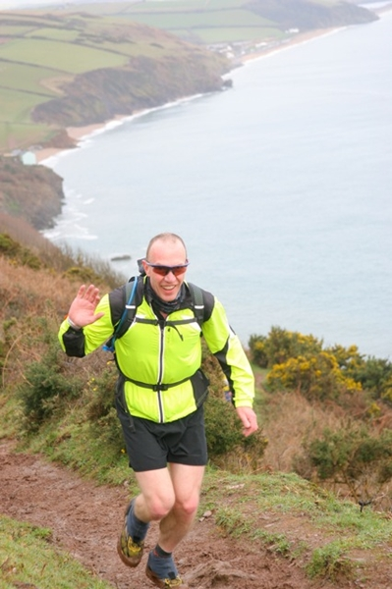
Rob pictured during one of his Ultra Races
1. Born to Run - Non-fictional book by Christopher McDougall about ultra-running, ultra-marathoners and a unique race in South America with a hidden tribe. Reads like a novel and introduces some interesting c haracters and the phenomenon of bare-foot running. Makes me want to run really long distances. One of the two best books about running I have read.
2. Feet in the Clouds - Non-fiction account of fell running and fell runners by Richard Askwith. This is the Fell running equivalent of "Born To Run". Great read. There are some crazy runners out there and the book makes me want to be one of them. The other best book about running that I have read.
3. The Marathon Makers - Fantastic book by John Bryant that recounts the 1908 Olympic marathon in London and the events immediately after that raised the marathon to the height of popularity. This was the race that set the official distance for the marathon that has been used ever since. Really inspiring.
4.Once a runner - by John L. Parker, is the best fictional book about running ever written. A really inspiring and eloquent book that follows the main character's hard work an d dedication in trying to achieve his personal goals. Written by a runner for runners.
5. Running On Empty - A selection of articles by former Runners World journalistAndy Blackford that recount his somewhat haphazard running career. Extremely funny and enjoyable.
6. Running Through The Wall - A selection of stories from renowned ultramarathoners providing great insights into the challenges and pleasures of long distance running and the personalities and camaraderie encountered. Great to see how many crazy people there are out there. I found this a very motivational read.
7. What I Talk About When I Talk About Running (Book) - Novelist Haruki Murakami's hugely enjoyable reminiscences about his preparation for the 2005 New York City marathon. Really good writing style that makes me want to read one of his novels.
8. Duel in the Sun - Great account by John Bryant of the 1982 Boston Marathon when Dick Beardsley and Alberto Salazar put on an amazing exhibition of competitive running in the race that became known as the "duel in the sun". My favourite road marathon has delivered a number of great stories over the past 114 years, this is just one of them.
9. Just A Little Run Around The World - Rosie Swale-Pope's inspirational story documenting her 5 year long run around the world following the loss of her husband. As interesting for the different people and places she encounters than for the running feat itself.
10. Why We Run - Interesting book by Bendt Heinrich. Part biography, part biological/anthropological text, and part psychological and philosophical study. All of it helped along by an obvious passion for running. Thanks to Jim for introducing me to this great book.
OnTrac k Sports Therapy - South Woodford
DISCOUNTED sports massage, injury assessment and treatment.
OnTrack Sports Therapy is a new sports injury clinic that is located on George Lane in South Woodford. The ethos of the company is largely community based and they aim to help any athlete whether amateur or elite level by providing professional and expert sports injury management.
They offer a variety of treatments, which include:
•Injury assessment, diagnosis and treatment
•Tailored treatment plans
•Post-op rehabilitation and gait re-education
•Injury rehabilitation
•Sports massage
•Joint and spinal mobilisations
East London Runners have obtained a 10% discou nt on injury assessment, treatment and rehabilitation. In addition East London Runners can have a 1/2 hour sports massage for only £20 or 1 hour for £40 on Monday evenings from 6pm-10pm in order to help stay on top of any aches and pains.
For full details click for the leaflet here
Room 8, 10 The Shrubberies
George Lane
South Woodford
E18 1BD
Mondays
6pm - 10pm
www.ontracksportstherapy.co.uk/
Runners Shorts!
by Long Legs
Strength and Stamina training - The Glade.
Over 50 runners recently attended a regular Wednesday night run, organised by Doug Mansell. The session included at least 8 runs up and down The Glade in Wanstead Park.
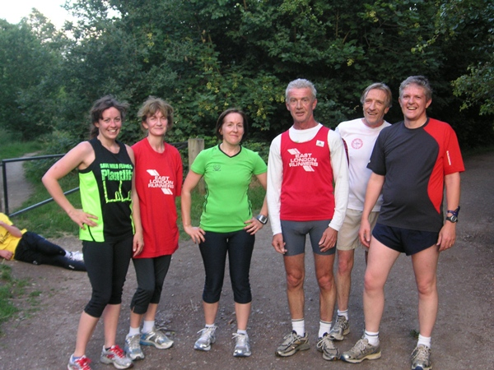
Louisa Tock, Mary Connolly, Andrea Waller,John White, Dave Knight and Edward Barnard all look happy after completing the Glade training session.
London to Brighton Walk - Saturday and Sunday June 11/12th 2011.
Congratulations to ELR's JIM BIRD and PAUL CHARTERS in completing this 100k walk in tough conditions, through Saturday night and into the heavy rain of Sunday. A fantastic achievement. As a large group of intrepid trekkers gathered in South West London on the morning of Saturday 11 June, onlookers soon concluded that this was no ordinary weekend walk! 100 kilometres and 1 day later our wearied teams of adventurers dragged themselves across the finish line in Brighton, tired but jubilant, and all in aid of blind heros, ex-Service men and women supported by St Dunstan's.
Walk Breaks? An interesting read by Jeff Galloway.
Most runners will record significantly faster times when they take walk breaks because they don't slow down at the end of a long run. Thousands of time-goal-oriented veterans have improved by 10, 20, 30 minutes and more in marathons by taking walk breaks early and often in their goal races. You can easily spot these folks. They're the ones who are picking up speed during the last two to six miles when everyone else is slowing down.
The mental benefit: breaking 26 miles into segments, which you know you can do Even sub-three hour marathoners continue to take their walk breaks to the end. One of them explained it this way: "Instead of thinking at 20 miles I had six more gut-wretching miles to go, I was saying to myself one more mile until my break.' Even when it was tough, I always felt I could go one more mile.
Read more at http://www.jeffgalloway.com/
Barefoot Running UK is holding a two day Foundation & Principles workshop in London on 13th and 14th August. The workshop will cover anatomy, biomechanics, barefoot running and how to incorporate it into training for optimum technique, injuries, exercises,etc. The workshop is for anyone interested in improving their running form and reducing injury. Full details here http://www.barefootrunninguk.com/
Charity Run opportunities.
1. British 10k race, Sunday 10th July 2011 - The Susy Lamplugh Trust
Over 25,000 runners including top athletes and celebrity runners will run the eleventh anniversary of the British 10k race. The race starts in Hyde Park and winds its way through the heart of Lond on passing many iconic sights on the way. Much of this route will also be used for the Men’s Marathon in the Olympics 2012. www.suzylamplugh.org/
2. The Action for Brazil's Children Trust. We have some places left in the 10K London Run happening on the 10th July 2011www.abctrust.org.uk
parkrun has now begun each Saturday morning at 9am at Wanstead Flats, Valentines Park and Hackney Marshes. FREE ENTRY but you have to register in advance.www.parkrun.org.uk/wansteadflats/home
If you have a story that you would like to share with your fellow East London Runners, or should you wish to have your personal race reviews published, please contact us via the webmaster email link here:
webmaster@eastlondonrunners. org.uk

Visit our website at www.eastlondonrunners.org.uk or our Facebook page

