EAST LONDON RUNNERS – elrNEWSLETTER – September 2011

EAST LONDON RUNNERS win ELVIS Summer Race Series
ELR win both Ladies and Mens Team Competions plus Individual Category Prizes!
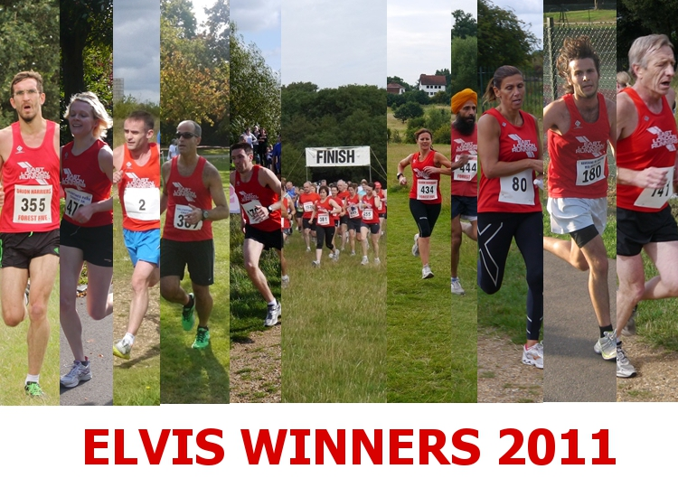
ELR Elvis Ladies Team Captain Karen said "Another great turn out on a beautiful sunny late September morning at Valentines Park for the final race of the series, 36 runners from East London Runners comprising 12 ladies and 24 men – a fantastic representation of what our club has become.
Over the whole 7 race series the ELR Ladies team won all seven events, a great achievement. After the race day presentations were complete the prizes were also presented for the overall categories of the ELVIS series with East London taking the lions’ share. We took both men’s and women’s team events (previously dominated by Ilford AC in both), with myself and Brendan O'Grady winning overall individual categories, Ciaran Canavan narrowly winning a hard fought second overall in the men's,Helen Ringham coming third overall in the ladies, Ava Lee 1st Vet 35 and Mary O'Brien taking 1st Vet 55. Edward Barnard won the prize for the best Elvis costume one again!
On behalf of myself and Grant, team captains, we would like to thank everyone
who ran, supported and marshalled along the way. You all contributed in our
great achievement in this series and have helped the club go from strength to
strength. Not in my 21 years of being a member of this club have I witnessed
such togetherness and camaraderie amongst our runners – it’s great to be a part
of and long may it continue.
The day was finished off with about 26 members meeting in the evening at The George, Wanstead for a well deserved drink and for all those not present I think Ciaran probably had your share!!!
Grant said. "ELR Ladies finished first in all 7 races. Men first in 6 and 2nd at Orion but a landslide victory in both genders. Well done to all our 72 runners and supporters in the series, marshalls yesterday and the club committee. Let's try and make it a 100 different runners in the 2012 series!"
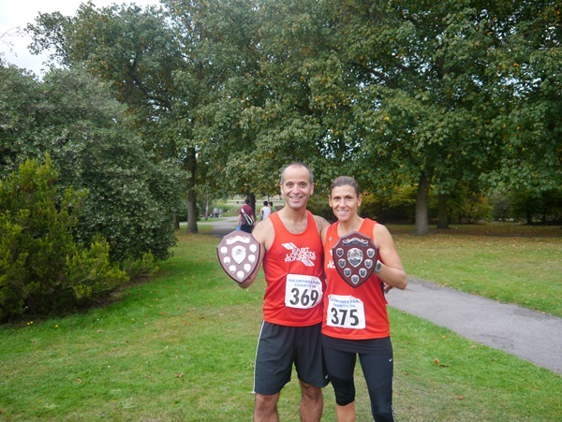
ELR Team Captains Grant and Karen proudly show off the Team trophies!
ELVIS Race 7- Valentines Park 5k - Sunday 25th September 2011
The final race in the ELVIS 5k and 5 miles series for 2011!
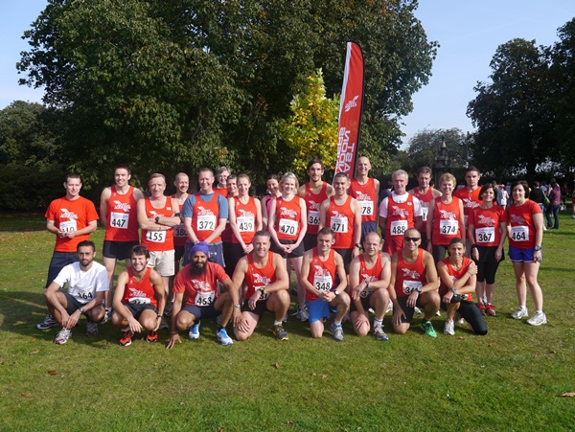
Brendan O'Grady | 16:24 | 2nd
Ciaran Canavan | 17:12 | 7th
Mark Boulton | 17:32 | 11th
Patrick Brown | 18:01 | 15th
James Wilson | 18:27 | 19th
Andrew Baxter | 18:31 | 20th
Danny Lee | 18:42 | 21st
Manjit Singh | 18:50 | 23rd
Shahib Ali | 19:04 | 27th
Dave Periera | 19:15 | 28th
Karen Levison | 19:33 | 30th - 1st Lady
Sam Browne | 19:36 | 31st
Derek Wright | 20:00 | 36th
Mick Wilson | 20:20 | 41st
Ava Lee | 20:26 | 42nd - 2nd Lady
Grant Conway | 20:53 | 47th
Richard Potter | 21:05 | 51st
George Georgiou | 21:08 | 53rd
Matthew Jones | 21:21 | 59th
Joanne O'Sullivan | 21:25 | 61st
Andrea Waller | 21:35 | 64th
Helen Ringham | 21:44 | 65th
Ramesh Pala | 21:47 | 67th
Paul Thompson | 22:04 | 72nd
Richard Guest | 22:20 | 75th
John White | 23:28 | 90th
Rachel Coombs | 23:41 | 95th
Tricia O'Neill | 24:25 | 105th
Mary O'Brien | 24:27 | 106th
Edward Barnard | 24:36 | 109th
Dave Knight | 24:51 | 112th
Anna Phillips | 25:17 | 119th
Mary Connolly | 25:42 | 122nd
Jayne Browne | 26:26 | 130th
Sheila Kennedy | 26:48 | 134th
Michael Rose | 26:55 | 135th
180 finishers including - 36 East London Runners ( 12 Ladies & 24 Men)19 Ware Joggers,18.Ilford AC,17 Eton Manor,15 Havering,12 Dagenham,8 Barking and 5 Orion.
To read the race report please click here
ELVIS Race 6 - Dagenham 88 5 mile'sh - Sunday 11th September 2011
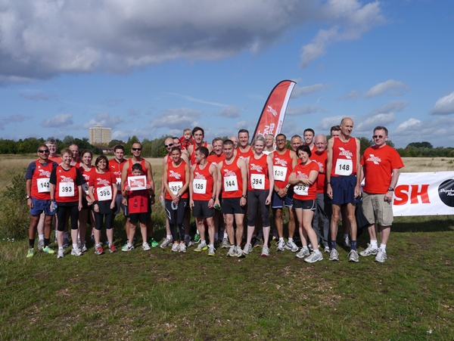
Brendan O'Grady | 30:21 | 1st - Race Winner!
Ciaran Canavan | 31:07 | 2nd
Mark Boulton | 32:40 | 6th
Manjit Bedi | 33:20 | 8th
Danny Lee | 34:31 | 13th
Karen Levison | 36:13 | 18th - First Lady!
Samuel Browne | 36:44 | 20th
Carlton D'Souza | 36:54 | 21st
Derek Wright | 37:14 | 22nd
Mick Wilson | 38:10 | 25th
Ava Lee | 38:34 | 27th - 1st Lady Vet
Grant Conway | 38:39 | 29th
Richard Potter | 38:56 | 30th
Patrick Farren | 39:37 | 36th
George Georgiou | 39:59 | 40th
Jamie Coombs | 40:02 | 41st
Doug Mansell | 40:51 | 44th
Paul Thompson | 41:10 | 47th
Andrea Waller | 41:37 | 49th
Ramesh Pala | 41:42 | 50th
Dave Knight | 46:03 | 62nd
Mary O'Brien | 46:17 | 63rd
Roger Dixon | 49:10 | 73rd
Jayne Browne | 49:57 | 77th
Sheila Kennedy | 50:41 | 78th
Juliet Bryant | 51:08 | 81st
Don Bennett | 54:05 | 88th
96 finishers. 27 East London Runners - 20 men and 7 ladies.
Video Footage by "Carry On Running" available on: YouTube
Prize winners from 5-ish. Men 1st Brendan O'Grady, 2nd Ciaran Canavan, 1st Men's teamTeam of 3 - Brendan, Ciaran and Mark Boulton. Ladies 1st Karen Levinson, 1st Female Vet 35 Ava Lee, 1st Ladies Team Team of 3 - Karen, Ava and Andrea Waller.
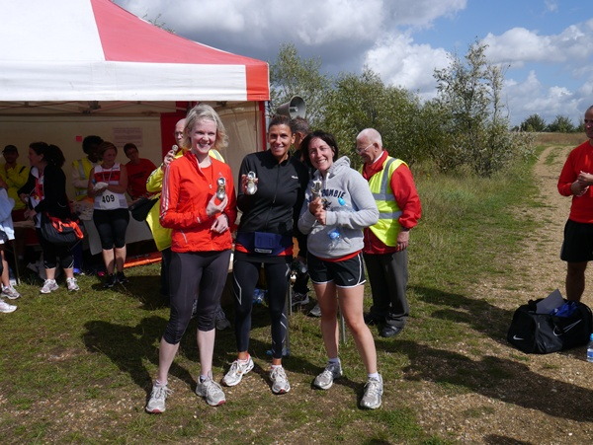
East London Runners - Ladies Team Winners - Ava, Karen and Andrea.
Grant's report. East London Runners made a triumphant return to Eastbrookend Park, Dagenham for the 6th race in the Elvis series. Following our success at the Barking 5k run at the same venue at the end of August ELR runners claimed the majority of the prizes available. The men's team won by a massive 75 points with Brendan and Ciaran excelling again, finishing 1st and 2nd. Our ladies had only 7 runners but strong performances from captain Karen who was 1st lady by a comfortable margin, followed by Ava who bravely battled on after feeling poorly at the halfway point.........To read the rest of the report please click here
ELVIS Race 5 - Barking 5k - Bank Holiday Monday 29th August 2011
ELR again win Ladies and Mens Team events to remain at the top of the Series tables.
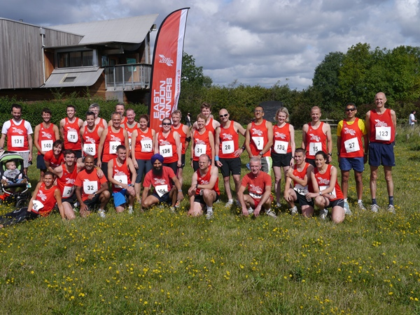
Most of the ELR team prior to the race. The others got lost on their warmup run but made the race start!
Brendan O'Grady | 16:41 | 2nd
Ciaran Canavan | 17:13 | 3rd
Mark Boulton | 18:00 | 6th
Manjit Bedi | 18:37 | 11th
Andrew Baxter | 18:46 | 15th
Manjit Singh | 18:54 | 17th
Danny Lee | 18:55 | 18th
Patrick Brown | 18:58 | 19th
James Wilson | 19:25 | 21st
Karen Levison | 19:44 | 22nd 1st Lady
Derek Wright | 20:10 | 26th
Mick Wilson | 20:25 | 27th
Ava Lee | 20:35 | 32nd 1st LV 35
Carlton D'Souza | 20:38 | 33rd
Richard Potter | 21:01 | 38th
Grant Conway | 21:10 | 42nd
George Georgiou | 21:25 | 46th
Patrick Farren | 21:39 | 51st
Jamie Coombs | 21:59 | 55th
Richard Guest | 22:17 | 58th
Ramesh Pala | 22:18 | 60th
Paul Thompson | 22:28 | 62nd
Joanne O'Sullivan | 22:32 | 63rd
Helen Ringham | 22:34 | 64th
Andrea Waller | 22:36 | 65th
Rachel Coombs | 23:54 | 79th
John White | 23:55 | 80th
Dave Knight | 24:01 | 81st
Suzanne Bench | 24:10 | 83rd
Sarah Burns | 25:34 | 100th
Don Bennett | 26:19 | 105th
Sheila Kennedy | 27:27 | 118th
148 finishers.112 from Elvis clubs. 32 East London Runners - 9 Ladies and 23 Men. 28 Havering, 24 Dagenham, 14 Ilford, 10 Eton Manor, 3 Orion and 1 Barking Road Runner. Video Footage by "Carry On Running" available on YouTube:
Part 1 , Part 2 Photos by "Carry On Running" available on Flickr here
Grant's report - On Bank Holiday Monday 32 ELR members made their way to the wilds of Eastbrookend Park, Dagenham for the 5th race in the ELVIS series, the Barking 5k which was moved to a new venue due to renovation works at Barking/Mayesbrook parks. A number of ELR members were familiar with the course having competed in the Dagenham 5 mileish which is run there in September (and shall be again on 11th Sept 2011 for ELVIS 6). The course cannot be considered as plum pb territory with a few tight turns, gravel paths and grass in various sections, however this didn’t stop two of our men achieving pb's which was an added bonus. Owing to the ELR excellent turnout which once again was the highest of the ELVIS Clubs the men and ladies dominated the race to say the least.....to read the rest of Grant's report please click here
Virgin London Marathon - April 22nd 2012
The results of the public ballot are due in the next week or so.
With the results of the Public Ballot due in the next week or so this is a timely reminder of the East London Runners Club Rules for our ballot for the places that the Club receive.
1. Open to Members where East London Runners is their fir st claim club.
2. Fully paid up Member by 1st July 2011 i.e. the year prior to the year the marathon is being held.
3. Applied in the public ballot and was rejected by VLM for 2012.
4. Can provide proof to the Club of being rejected by VLM 2011. Proof by
way of rejection slip/letter or e.mail from VLM 2012. Note a rejection magazine or copy of same is insufficient.
5. Member to advise that they wish to be in the ballot and provide proof of rejection by Wednesday 23rd November 2011.
6. The draw will take place on Wednesday 30th November 2011.
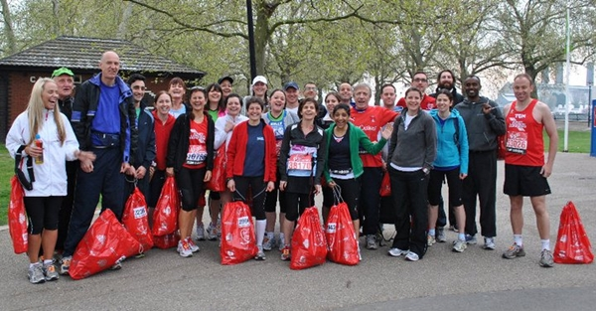
East London Runners members on the morning of the 2011 Virgin London Marathon.
If you are unsuccessful in the Public and Club place you should consider running for a Charity! SENSE have lots of charity Gold Bond places available in the 2012 Virgin London Marathon and would really like to offer some to our Club ru nners. In recognition of the time that club runners put into the sport, they are offering places with a discounted fundraising target of £1,200 (normal requirement is £1,500) + £100 registration fee.
If you are interested please contact SENSE either by phone on 0845 127 0063 or by e.mail marathon@sense.org.uk quoting East London Runners Running Club Offer.
Other Spring Marathon Options.
Jerusalem Marathon - Sunday March 16th 2012.
Currently recruiting runners to run with Team Shalva. It is an incredible opportunity for serious runners to tackle the grueling hills of Jerusalem, a city renowned for its rich culture and heritage. Runners can opt to do the 10km, half or whole marathon.http://www.run4shalva.org
Brighton Marathon - Sunday 15th April 2012.
The Brighton Marathon is a great alternative to the London Marathon. Open to 15,000 runners, the route encompasses bo th the historic city and stunning coastal views. As a predominantly flat and fast course it lends itself to be an enjoyable day for both runners and supporters. Run for Breast Cancer Care -
http://www.breastcancercare.org.uk
Milton Keynes Marathon - Sunday 29th April 2012.
Starting and finishing at 10am at MK Stadium,Stadium Way, Milton Keynes, Buckinghamshire, MK1 1ST. Entry limit 6,500.
http://www.miltonkeynesmarathon.co.uk/
Chingford League and Sunday Cross Country League
East London Runners has joined the Chingford League!
At a meeting of the full Management Committee of the Club on Wednesday 1st June 2011 it was agreed that we apply for membership to the Chingford League. The Chingford League have advised that they are happy to accept us.
Entry to all races in both Leagues is FREE to all Club Members. You just turn up at each event and will be given a race number! It is usual to car share to those races which are not local with many members meeting at Wanstead Leisure Centre prior to travel. Please support Both Leagues!
Chingford League Fixtures 2011/2012.
Tues 4 Oct 2011 - 8pm - 5k race at Redbridge Cycle Circuit, Forest Road, Hainault, Ilford, IG6 3HP.
Sat 15 Oct 2011 - 2.30pm -5m race at Trent Park (Cockfosters Entrance)
Tues 1 Nov 2011 - 8pm 5k - 5k race at Redbridge Cycle Circuit, Forest Road, Hainault, Ilford, IG6 3HP.
Sat 26 No v 2011 - 2.30pm - Alexandra Palace.
Sat 21 Jan 2012 - 2.30pm - Probably at Orion
Sat 18 Feb 2012 - 2.30pm - Victoria Park.
Sat 17 Mar 2012 - 1.00pm - Relays at Heighams Park, Junior race at 1pm, followed by Senior race.
Club's competing in the Chingford League are East London Runners, Orion Harriers,Barnet AC, Trent Park, Eton Manor, Victoria Park, Enfield & Haringay, Loughton, Woodford Green & Essex Ladies.
In addition ELR will continue to compete in the Sunday Cross Country League.
2011-2012 Fixtures - Note, all races now start at 10.30am.
Sunday 23rd October 2011 - Cheshunt
Sunday 20th November 2011 - Trent Park, Cockfosters
Sunday 11th December 2011 - Watford
Sunday 15th January 2012 - Tewin/Digswell
Sunday 19th February 2012 - Royston
Sikh Relay Marathon - Sunda y 28th September 2011
East London Runners triumph in a new race record time!
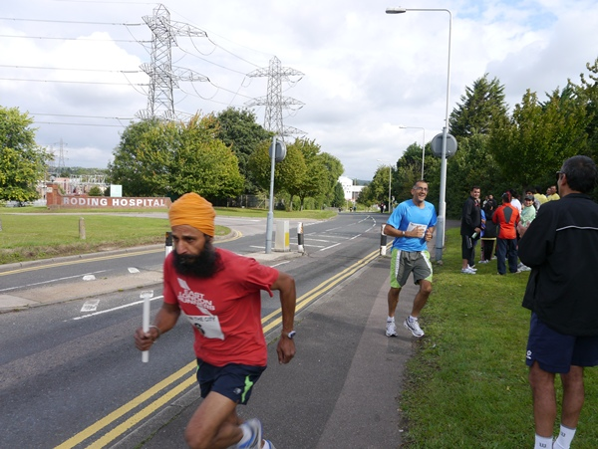
Manjit Singh in full flow after Manjit Bedi's race leg.
This is an annual event involving the Sikh community and local running clubs.
It consists of a course measuring 2.022km which is run by a team 21 times to
constitute the marathon distance of 42.2km. The stretch down Woodford Avenue,
which measures 800m, and the uphill on Roding Lane South are familiar to ELR
members, albeit from dark Wednesday evenings rather than a bright Sunday
morning. The start and finish of each lap were at the grassy verge opp osite
Roding Hospital.
There were five or six serious teams taking part, plus other teams who were
enjoying it as a fun morning out. ELR fielded two teams, one comprising five
men, the other five men and a lady (Suzanne). There was a danger that the six-
person team would only consist of four runners, thereby making it one short of
the required minimum, until Dave and Ramesh turned up shortly after the race
had started to sighs of relief all round. Both Barking RR and Ilford AC were
missing this year - perhaps they were saving themselves for the Elvis 5k the
following day. This was a plus in that our five-man team secured an easy first
place, having come second in the previous two years. It was a minus in that
the course was sparsely populated by runners (though there were lots of parents
and children walking), thereby making the experience a little lonely as there
was no one much to chase.
Nevertheless, Derek hopped on his bike to accompany Manjit Singh up the final
hill to the finish where he was egged on to a course record by the cheering
crowd of runners and spectators.
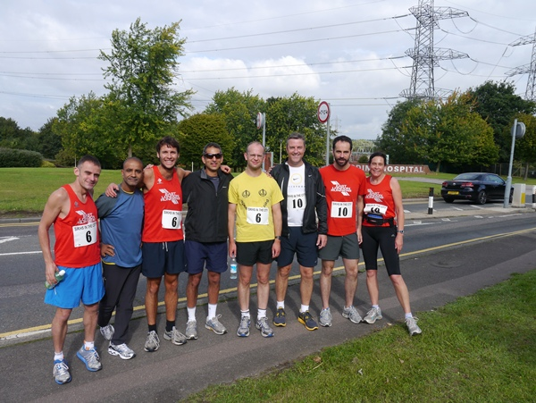
Members of the East London Runners teams who competed in the Sikh Marathon relay.
Essex Way 82 miles Team Relay Race - Sunday 4th September 2011
ELR unable to field full teams in this year's event.
Disappointing in that ELR was unable to field a full team in this year's event owing to holidays, injuries, late call offs and travel problems.
Edward's race report.
Everyone who managed to run had a good time on Sunday, participating in the
Essex Way event. Starting at 8am prompt, the first two runners of Aaron and
Caiomhe finished really well, despite a small mid-course diversion by Caiomhe
and the group she was running with [I’d cleared the fallen tree the leader was
using as a marker].
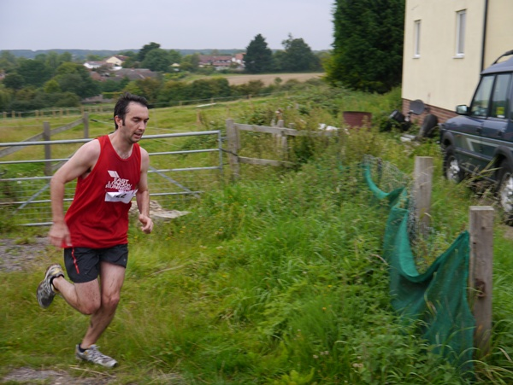
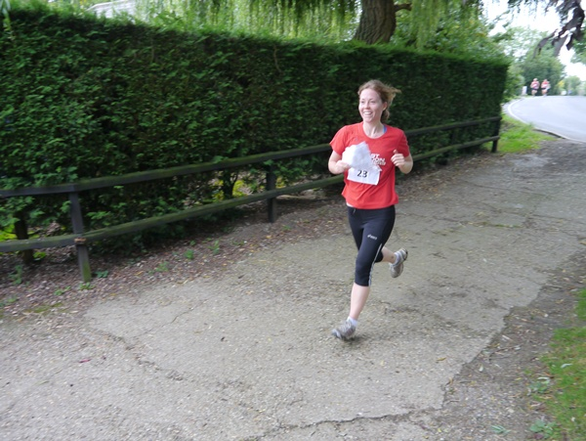
Aaron Williams and Caiomhe O'Reilly running through Toot Hill during the
first leg of the Essex Way Team Relay event.
Grant and Sarah accomplished the second leg, and impressively kept going to
complete the third leg as well (a total of nearly 20 miles), as a very effective
marathon training effort; meanwhile Derek and Jayne also ran t he third leg, just
missing the start of the fourth by David and Trish who only just squeaked in to
start with the others.....to read the rest of Edward's report click here
Runners Shorts!
by Long Legs
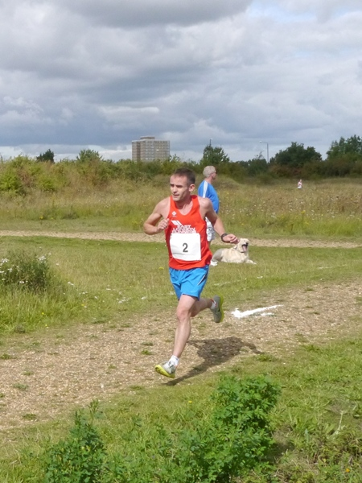
Ciaran in a previous race.
Congratulations to Ciaran Canavan on completing the Great North Run (Half Marathon) on Sunday 18th September 2011 in a personal best time of 1 :15:16 in 61st place in a field of 54,000!
Congratulations also to Carinne Jay in winning the prize for first Lady in the Copped Hall 5 mile race on Sunday 25th September 2011 in a time of 37:46.
NEW - The Walden Duathlon 2011 - Sunday 20th November 2011.
• Seniors, TriStars 1,2,3 & Youth Categories. Suitable for both novices and
experienced athletes. Multi-terrain run route. Off road mountain bike leg - with a few surprises. Based at the old airfield near Carver Barracks (Saffron Walden)
• Ample parking/changing/shower facilities on site.
In support of Carver Barracks’ Injured Soldiers Fund.
http://www.waldentri.co.uk/
Free Circuit Training if you live aound the Ilford/Seven Kings, Newbury Park area. Get Fit & Stay Fit With Circuit Training At Canon Palmer Catholic School.Entrance in Lombard Avenue, Seven Kings. Mondays 6.45pm-8.00pm. You’ll find it ch allenging,varied and rewarding. A wide range of exercises and training techniques to improve every element of your fitness. All carried out under the guidance of a Registered Exercise Professional (REP) in a friendly environment.
Males and females of all abilities welcome. Contact Suki if you require more information or better still come along and see for yourself.
Contact: Suki Jandu, 07707-067757.
Brentwood Running Festival - Saturday and Sunday 29/30th October 2011.Saturday, Childrens 2k and Adult 10k. Sunday, Half and Full Marathon. Weald Country Park, Brentwood, CM14 5QS. Beautiful circuit of varied off road running, includes grassland & lakeside running, short challenging climbs and fantastic forest trails. All races will be chip timed in 2011. NEW for 2011 - Hotel and Prize sponsorship from Holiday Inn offering a discounted race weekend stay, and the chance to win gym membership, gym essential pack, or a romantic break. All athletes will receive a commemorative race T-shirt, and free refreshments, and Sundays runners will also receive a race medal!
http://www.gobeyondultra.co.uk

Visit our website at www.eastlondonrunners.org.uk or our Facebook page

