EAST LONDON RUNNERS – elrNewsletter – OCTOBER 20112

Sunday Cross Country League - Race 1 Cheshunt - 23rd October 2011
ELR compete in the first XC League race over a 5 mile course.
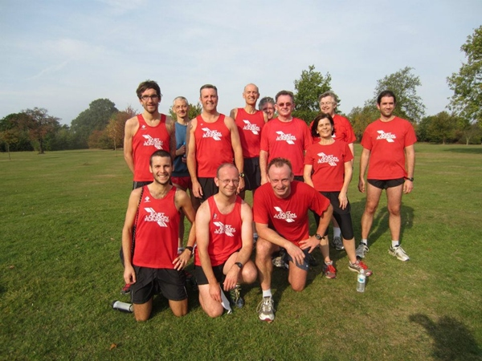
Mark Boulton | 31:07 | 24th
Patrick Brown | 31:36 | 33rd
Derek Wright | 34:43 | 90th
Mike Wilson | 36:12 | 118th
Paul Thompson | 38:51 | 161st
Doug Mansell | 38:56 | 163rd
Miguel Martinez | 39:59 | 181st
Jimmy Hartwell | 40:17 | 187th
Edward Barnard | 43:23 | 228th
Frank Brownlie | 43:42 | 231st
Jayne Browne | 47:22 | 260th
Don Bennett | 48:40 | 274th
ELR were back at Cheshunt for the first race of this season's Sunday league. It was the course we have come to know and love, consisting of three fairly hilly laps, at about the same level of difficulty as the Orion Forest 5. It was beautiful weather for it, and the ground was firm underneath, and never wet. Doubtless due to the fine autumn weather, there were over 300 runners competing, many of whom went round in road shoes. By the first half of the third lap, we could feel the sun baking down on the back of our necks as we pushed up the two long hills.
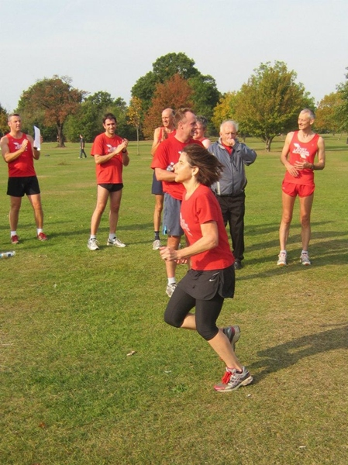
Jayne Browne finishing strongly.
Mark, Patrick and Jayne were Sunday league newbies, while Paul and Frank were new to the event. Some of the regulars complained of being overtaken by the winners in their second lap. The men fielded 11 runners, three more than the required number for a team. The ladies' team consisted of Jayne and the onus falls on her to rally support from ELR ladies for the next race at Trent Park in November. Thanks also to Jim Bird for taking photos.
Remaining Sunday Cross Country League Fixtures - 2011/12
Note, all races now start at 10.30am.
Sunday 20th November 2011 - Trent Park, Cockfosters.
Sunday 11th December 2011 - Watford.
Sunday 15th January 2012 - Tewin/Digswell.
Sunday 19th February 2012 - Royston.
Social Events
10 Pin Bowling in November and Xmas Dinner in December
10 Pin Bowling at Westfield, Stratford City.
Doug has booked 3 lanes for 1 game at 8pm on Thursday 10th November 2011 at All Star Lanes at Westfield which should last about an hour. The cost is £7 each for 21 people (7 per lane).
We need names and money by 3rd November. E.mail the Webmaster or advise Doug/Don on a Club run.
Christmas Dinner at The George, Wanstead on wednesday 14/12/2011.
East London Runners Christmas Dinner at The George on Wednesday 14th December at 9pm.
£5.00 club members , £6.99 non members for Christmas Dinner and a drink.
1 Roast Turkey with all the trimmings.
2 Portobello Mushroom,Chickpea & pumpkin Seed Roast (V)
3 Salmon Fillet with chips & side salad.
Choose from list of drinks on the night.
Add a starter for £2.00, 2 courses £7.00.
4 Chicken Liver & Bacon Pate
5 Broccoli & Shropshire Blue Cheese Soup (V)
6 Organic Tomato & Basil Soup (V)
Add a dessert for £2.00, 3 courses £9.00.
7 Christmas Pudding with hot custard
8 Christmas Pudding with brandy sauce
9 Eli's Original Baked Vanilla Cheesecake (V)
Email your choices to the webmaster or see Don on a clubnight.
Virgin London Marathon - April 22nd 2012
The public ballot results are now known!
With the results of the Public Ballot now known this is another timely reminder of the East London Runners Club Ballot Rules for the places that the Club receive.
1. Open to Members where East London Runners is their first claim club.
2. Fully paid up Member by 1st July 2011 i.e. the year prior to the year the marathon is being held.
3. Applied in the public ballot and was rejected by VLM for 2012.
4. Can provide proof to the Club of being rejected by VLM 2011. Proof by
way of rejection slip/letter or e.mail from VLM 2012. Note a rejection magazine or copy of same is insufficient.
5. Member to advise that they wish to be in the ballot and provide proof of rejection by Wed nesday 23rd November 2011.
6. The draw will take place on Wednesday 30th November 2011.
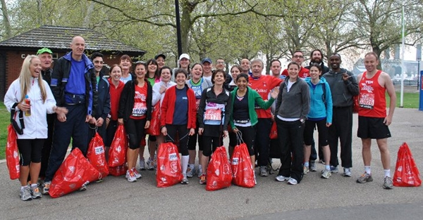
East London Runners members on the morning of the 2011 Virgin London Marathon.
If you are unsuccessful in the Public and Club place you should consider running for a Charity! SENSE have lots of charity Gold Bond places available in the 2012 Virgin London Marathon and would really like to offer some to our Club runners. In recognition of the time that club runners put into the sport, they are offering places with a discounted fundraising target of £1,200 (normal requirement is £1,500) + £100 registration fee.
If you are interested please contact SENSE either by phone on 0845 127 0063 or by e.mail marathon@sense.org.uk quoting East London Runners Running Club Offer.
Other Spring Marathon Options.
Jerusalem Marathon - Sunday March 16th 2012.
Currently recruiting runners to run with Team Shalva. It is an incredible opportunity for serious runners to tackle the grueling hills of Jerusalem, a city renowned for its rich culture and heritage. Runners can opt to do the 10km, half or whole marathon.http://www.run4shalva.org
Brighton Marathon - Sunday 15th April 2012.
The Brighton Marathon is a great alternative to the London Marathon. Open to 15,000 runners, the route encompasses both the historic city and stunning coastal views. As a predominantly flat and fast course it lends itself to be an enjoyable day for both runners and supporters. Run for Breast Cancer Care -
http://www.breastcancercare.org.uk
Milton Keynes Marathon - Sunday 29th April 2012.
Starting and finishing at 10am at MK Stadium,Stadium Way, Milton Keynes, Buckinghamshire, MK1 1ST. Entry limit 6,500.
http://www.miltonkeynesmarathon.co.uk/
Essex Vets Cross Country Championship Races - Chigwell Row - Saturday 3rd December 2011
Ladies over 35 and Men over 40 required to represent ELR.
The Essex Vets Cross Country Championships are to be held on Saturday 3rd December 2011 at Hainault Forest, Chigwell Row, IG7 6EN.
11.00am - Over 50's Men and Over 35's Women.
12 noon - Over 40's Men.
These are popular local races for Vets. Entry confirmation requir ed by Wednesday 2nd November 2011. Please advise the webmaster by e.mail or Don, Mike or Frank on a Club night
Fast Girls!
New Feature Film about running!
From Joey Coughlin, former pupil of Wanstead High School, who is working on a feature film which is set in the world of Athletics called "Fast Girls".
As the 2nd Assistant Director part of my job here is searching for people that would like to come along and be extras in our film. I have attached an email that with the support of UK Athletics is being sent around all U.K Clubs over the next few days. In particular we are looking for females that can be part of fictional 4x4 100 metre relay teams from around the world, but we also need officials and coaches that will be track side as the races take place. Our main locations will be Lee Valley and Crystal Palace stadium and filming will take place during November and December. We are very fortunate to have Jeanette Kwakye training our cast and she will be on hand during filming to offer tips and advice to those taking part.
If you think that you may be interested in coming along please pass read thefollowing email.
Dear Athletics Club member
We need you!
Would you like to be involved in the making of a movie? We need athletes to take part in the races, and crowd extras to cheer them on!
FAST GIRLS, is an exciting feature film about athletics that is coming out next summer. The production team are currently working with UK Athletics on a number of areas to make the athletics events shown in the film as exciting and authentic as possible and this is why we wanted to contact you as athletes and athletics fans. We are looking for athletes who would be interested to audition to be 'athlete extras' in the film and athletics enthusiasts who would like to be in the crowd in the film. The filming is taking place in London during late November and early December, full details and how to apply can be found on the link below. Please do not reply to this email but go to the website below for more information or to apply.
http://www.fastgirlsthemovie.co.uk/#take-part
The film, 'FAST GIRLS' is about two women from opposite sides of the tracks who have to overcome their differences to run the race of their lives in the 100M relay to beat the best in the world. Its climax is set in a fictional 2011 World Championships in London. There is also action at an Eu ropean build- up event and a regional qualifier.
Best wishes and we look forward to hearing from you.
The Fast Girls Production Team
Chingford League
East London Runners has joined the Chingford League!
Entry to all races in the League is FREE to all Club Members. You just turn up at each event and will be given a race number! It is usual to car share to those races which are not local with many members meeting at Wanstead Leisure Centre prior to travel. Please support the Chingford League!
Remaining Chingford League Fixtures 2011/2012.
Tues 1 Nov 2011 - 8pm 5k - 5k race at Redbridge Cycle Circuit, Forest Road, Hainault, Ilford, IG6 3HP.
Sat 26 Nov 2011 - 2.30pm - Alexandra Palace.
Sat 21 Jan 2012 - 2.30pm - At Orion
Sat 18 Feb 2012 - 2.30pm - Victoria Park.
Sat 17 Mar 2012 - 1.00pm - Relays at Heighams Park, Junior race at 1pm, followed by Senior race.
Club's competing in the Chingford League are East London Runners, Orion Harriers,Barnet AC, Trent Park, Eton Manor, Victoria Park, Enfield & Haringay, Loughton, Woodford Green & Essex Ladies.
Runners Shorts!
by Long Legs
Good luck to Sarah Burns, Ciaran Canavan and Peter Hatley running in the Dublin Marathon on Monday 31st October 2011.
October Marathon Results. Well done to the following East London Runners.
George Georgiou completing the Jersey Marathon in very hot conditions in 4:12:25 in 192nd place.
Grant Conway in a personal best time of 3:44:49 in 650th place in the Chester Marathon.
Manjit Singh in Toronto finishing in 484th place in a time of 3:36:17.
Personal bests recently for Steven Bywater in the Gt Eastern Half Marathon in 1:54:51. Helen Ringham in the Cardiff Half Marathon in 1:38:15. Mark Boulton in the Ware 10 mile in 1:03:20.Sarah Burns completing the Maidstone Half Marathon in 1:54:05.
Running in the News.
11th October 2011 - Marathon cheat catches bus for six miles to take bronze medal in race
11th October 2011 - Woman gives birth hours after running Chicago Marathon
NEW - The Walden Duathlon 2011 - Sunday 20th November 2011.
• Seniors, TriStars 1,2,3 & Youth Categories. Suitable for both novices and
experienced athletes. Multi-terrain run route. Off road mountain bike leg - with a few surprises. Based at the old airfield near Carver Barracks (Saffron Walden)
• Ample parking/changing/shower facilities on site.
In support of Carver Barracks’ Injured Soldiers Fund.
http://www.waldentri.co.uk/
Free Circuit Training if you live aound the Ilford/Seven Kings, Newbury Park area. Get Fit & Stay Fit With Circuit Training At Can on Palmer Catholic School.Entrance in Lombard Avenue, Seven Kings. Mondays 6.45pm-8.00pm. You’ll find it challenging,varied and rewarding. A wide range of exercises and training techniques to improve every element of your fitness. All carried out under the guidance of a Registered Exercise Professional (REP) in a friendly environment.
Males and females of all abilities welcome. Contact Suki if you require more information or better still come along and see for yourself.
Contact: Suki Jandu, 07707-067757.

Visit our website at www.eastlondonrunners.org.uk or our Facebook page

