elrNEWSLETTER March 2011

ORION 15 - Saturday 19th March 2011
Results from this annual classic race.
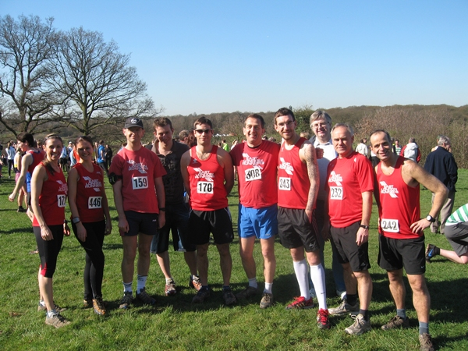
Sharon, Tricia, Derek, Dave Pereira, James, Richard, Mark, Don, Patrick and Grant looking relaxed before the race!
James Wilson | 1:59:28 | 85th
Derek Wright | 1:59:33 | 89th
Danny Lee | 2:00:47 | 95th
Mark Boulton | 2:03:14 | 114th
Patrick Brown | 2:05:44 | 127th
Sharon Springfield | 2:15:25 | 193rd
Patrick Farren | 2:18:26 | 217th
Richard Mainwaring | 2:20:48 | 226th
Grant Conway | 2:22:41 | 238th
Tricia O'Neill | 2:29:25 | 279th
326 Finishers.
A sunny afternoon at the start of spring brought 10 of our runners to this classic forest race starting at the Queen Elizabeth Hunting Lodge in Chingford. The weather had been fairly dry over the previous few weeks, yet as we lined up at the start there were two words on our mind: "hills" and "mud". A steady first three miles were almost enough to make us wonder what all the fuss was about, though the odd wide ditch kept us on our toes.
Soon we were heading west towards Chingford, up to the obelisk on Pole Hill and onto the downhill stretch in the direction of the reservoir. The next section around miles five and six was generally judged to be the hardest, as it contained three tough hills and some mud. We fought hard and eventually there was some respite as we hit the road and entered the golf course. Before long we were struggling down a muddy path and later hurdled a stile at the end of a path behind some houses.
By now, we were on the familiar route to High Beech and when we got there (mile nine), it was worthwhile gulping down water and stocking up on jelly babies at the only drinks station on the course. We quickly headed off into a section downhill through forest, along more road and back into the forest again. There were reports that some of the faster runners took a wrong turn around mile 11. It was also here that we faced our last serious challenge of the race, at "Vertical" Hill, which, for many, it seemed more efficient to walk up rather than run up, thereby saving energy for the flat bit back to High Beech.
At High Beech, we saw the 12-mile marker and crossed the main road into a straightforward section first undulating and then flat along well-established bridleways. A marshall assured us that there were no more hills, but of course this was not true as in the last half mile we were presented with the hill that we had come down at the start. The Royal Forest Hotel was visible at the top and we battled hard, negotiating bumps and mud, and turned right at the summit to the finish.
It was no mean feat to complete this race for all who took part and a great training run during the marathon season. On top of that, the event also turned out to be social: Frank, Mick, Don and John White, who have all completed the race in previous years, gave support at various points along the course.
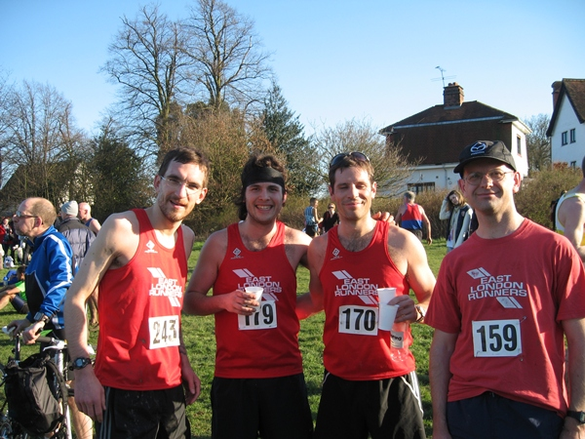
Mark, Patrick, James and Derek looking very happy having completed the tough 15 mile Orion course.
Virgin London Marathon 2011
Coach transfer.
This year we have booked a 33 seater coach for the London Marathon runners. Meeting at Wanstead Leisure Centre at 7.30am and an additional pick up at O'Neill's, Green Man roundabout, Leytonstone at 7.45am. The coach will drop off at Island Gardens DLR to either use the foot tunnel to Cutty Sark or the DLR (FREE to all competitors). Currently the tunnel is closed for refurbishment work so we'll find out nearer the time if it will reopen in time. It's usually a great way for the 1st timers who might be a little nervous to go with the regular runners and get to their starting points. Cost will be £5.00 for members. Currently have 30 places already booked, first come first served if you want a place. Already booked are Frances, Kelly, Clare, Carinne, Jayne, Katherine, Tricia, Tara, Kirsty, Juliet, Rachel, Katrina, Sarah B, Sarah R, Susannah, Laura, Victoria, Andrea, Priya, Grant, Michael, Simon, Jim, Abdi, Dave, Manjit Bedi, Tom, Thomas and Paul Charters. To reserve a place contact the Webmaster or Don on Facebook. Start to pay your money soon and state where you are picking up the coach, the Leisure Centre or O'Neill's. Don who will be at the Church Hall/Water Station has left Mike Wilson in charge of the coach on the day!
Afterwards you have to make your own way home. However, if you have the energy you can meet some of the Club Members for a post race drink at the Ship and Shovel Pub, 1-3, Craven Passage, Charing Cross, London, WC2N 5PH.1-3 , Craven Passage, Charing Cross, London, WC2N 5PH
www.fancyapint.com/pubs/pub1088.php
Virgin London Marathon 2011
Volunteers required to man the 20 mile Water Feed Station.
The Drinks Station is jointly organised by East London Runners and the London Fire Brigade. You are welcome to bring family and friends along with you, but please note (given the safety issues below) that this event is not suitable for children under 10 years old.
Once again we will be located adjacent to Tower Hamlets College (see map below). This is the 20 mile point on the course and will mean that we will finish about 2.30pm. If you can only manage a few hours then that will be fine also. Parking is limited, try the roads to the north of Poplar High St, but you may get blocked in by the closed roads. It is best to use Docklands Light Railway and get off at Poplar. Come down the stairs or lifts and pass between the College and Sports Centre. See location on this map. -www.mapometer.com/en/running/route_1118415.html
Please try to arrive by 9.00am so that you can help set up. We have 40,000 bottles of water to distribute and set out ready for the expected 34,000 runners.
Geoff Clennell will once again be providing a sound system to add to the local atmosphere. And Peter Cowup will add the "scintillating" commentary.
Safety. Although the road s are closed there will be some traffic, official or local, moving through the station. Please be alert and keep the road clear at all times. Competitors will follow the blue line on the road showing the shortest route. Please be careful with the sharp knives provided to cut open the packaging and do not overload the tables as they may collapse (2 layers only).
Setting up. We will have between 150-200 people helping out, divided between 12 tables. Each table will have an experienced table captain to co-ordinate things. The water station will be set up on both sides of the road, over a distance of 100m.
Clothing. We always hope for good weather, but bring waterproofs in case. All ELR helpers will receive Nestle shirts and hats as usual. Please wear them.
Refreshments/toilets. These are provided in St Mathias Church hall, where we will provide a buffet (which is free for all helpers), tea and coffee and access to toilets.
Sec urity. We have had a problem in the past with theft of water,but the fencing has addressed this. If you experience any problems let the stage area know immediately, so that appropriate response or police can be involved. If you have any valuables please take care. Do not hide them under tables, they will get wet. And once the tables run out of water, the tables will be folded up and cleared. Some valuables can be kept at the hall and locked up there.
Clearing up. We try our best to clear up at the end, many hands make light work and your help will mean this unpopular job can be completed in the shortest time possible. Bags, bins, brooms and shovels available.
London Fire Brigade. This is the 11th year the Brigade has been involved at the feed station and they use the chance to promote alarms and fire safety messages to the local community in the Borough of Tower Hamlets.
We also require some members for a few hours on the Saturday to help in setting up the scaffolding and other items required for the station.
Please advise Don Bennett, via the webmaster e/mail if you can assist on the day or on the Saturday.
Post Marathon Curry Night - Wednesday 20th April 2011
Come along and share your marathon experience with fellow members!
Following the success of the previous Curry Night in September 2010 we have arranged another at 9pm after the normal Club run on Wednesday 20th April 2011.
Again the venue will be 62Spice, 62 High Street Wanstead, opposite The George Public Ho use/Wanstead Tube Station.
Numbers are limited so please advise asap if you wish to attend by e.mailing the webmaster. At the same time please give your food order.
The cost is £13 per head with drinks extra. Please pay this amount in advance to Frank before or after any Club run prior to the above date.
Included in the cost is papadum & chutneys, rice/naan and vegetable side dishes and a main dish!
Each person needs to choose a main dish from chicken, lamb, prawn or vegetable and the type of curry required, from the following list:
Bhuna: slightly spiced and dry, packed with flavour
Rogan Josh: marinated in herbs and spices, cooked with fresh tomatoes
Korma: a mild dish cooked with cream and coconut (contains nuts)
Dupiaza: cooked with an array of spices, garnished with fried onions
Palak: spinach cooked with fresh herbs and spices
Madras: fairly hot, spicy and sour
Dhansak: a "parsee" dish - hot, s weet and sour with lentils
Pathia: slightly hot, sweet and sour flavour
Vindaloo: very hot and sour dish with potato
(Notes: the Madras, Dhansak and Pathia are "fairly hot", the Vindaloo
is "very hot")
Roding Valley Half Marathon - Sunday 27th February 2011
Results for East London Runners
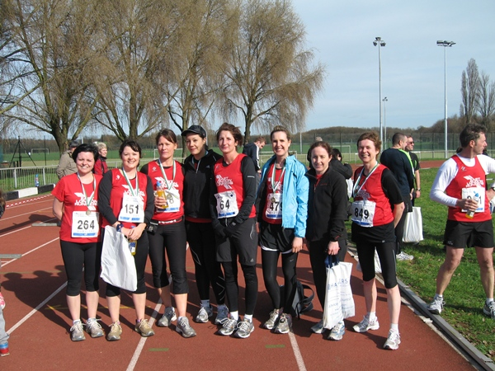
Frances Branch, Clare Waugh-Bachus, Susannah McLaren, Tara Syed, Angela Bowen, Katherine Jones, Katrina Dixon and Sheila Kennedy pictured together after the race.
Manjit Bedi | 1:21:55 | 38th
Andrew Baxter | 1:27:45 | 82nd
Aaron Williams | 1:27:48 | 83rd
Karen Levison | 1:30:40 | 111th
Thomas Whitney | 1:31:31 | 118th
Manjit Singh | 1:33:25 | 127th
Jamie Xavier | 1:36:07 | 127th
Russell Price | 1:36:42 | 167th
Mark Boulton | 1:37:33 | 190th
Patrick Brown | 1:39:19 | 209th
Richard Mainwaring | 1:39:41 | 118th
Grant Conway | 1:41:15 | 241st
George Georgiou | 1:41:57 | 261st
Jimmy Hartwell | 1:46:11 | 334th
Frank Brownlie | 1:46:47 | 338th
Tricia O'Neill | 1:50:07 | 391st
Caroline Meaby | 1:39:41 | 431st
Rachel Coombs | 1:51:25 | 453rd
Katherine Jones | 1:53:32 | 481st
John Atkinson | 1:54:34 | 514th
Victoria Elliott | 1:56:12 | 534th
Ramesh Pala | 1:59:45 | 608th
Andrew Rich | 2:02:06 | 625th
Katrina Dixon | 2:02:22 | 632nd
Baldev Singh | 2:02:23 | 481st
Laura Thrower | 2:02:35 | 639th
Sarah Rowling | 2:02:36 | 64thth
Michael Rose | 2:04:35 | 664th
Priya Patel | 2:02:06 | 676th
Sheila Kennedy | 2:06:36 | 689th
Frances Branch | 2:08:21 | 721st
Abdirahman Adan | 2:09:02 | 732nd
Angela Bowen | 2:09:06 | 734th
Tara Syed | 2:13:56 | 765th
Susannah McLaren | 2:13:56 | 766th
Dave Foster | 2:15:21 | 767th
Clare Waugh-Bachus | 2:16:35 | 786th
Kelly King | 2:26:04 | 838th
Jagdip Panesar | 2:29:27 | 841st
On a cold but dry and sunny morning 39 ELR members ran in the local half marathon.This resulted in East London Runners being the best represented Club in the race. The field of runners was the largest for many years and the organisers, having learned from the chaos at the start of last years race (in very heavy rain), had made strategic improvements to both the start and the finish of the race, with both being on the running track. With the race run around the local streets of Chigwell and Woodford Green marshalling of the runners was very important and again improvements were apparent in most road crossings although some car drivers continued to show impatience with the situation. For East London Runners Manjit Bedi was first male home followed by Andrew Baxter and Aaron Williams (running under his first claim club of Walthamstow). Karen Levison was our first lady to finish in 5th place overall for ladies and received prizes for first female vet. The race was also run as the Essex Championships and Karen received the Gold medal for the Female Vets and silver for Female Seniors. Congratulations to Karen.
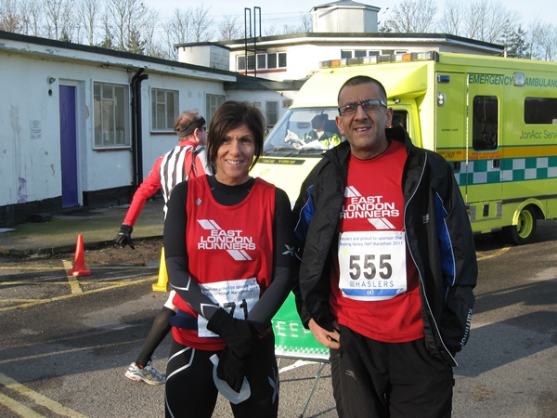
ELR leading runners Karen Levison and Manjit Bedi.
Many of our runners gained personal best times and a special well done to those completing a half marathon for the first time. For example, for sisters Frances Branch, Clare Waugh-Bachus and Kelly King, training for the Virgin London Marathon, this was their first time in completing 13.1 miles. A great personal achievment.
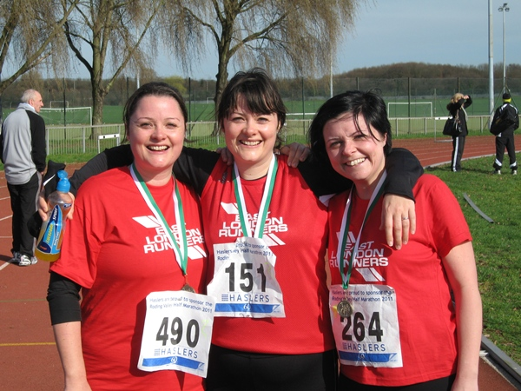
The Fitzpatrick Girls - Twins Kelly and Clare with sister Frances, happily pictured after the race.
Frances said "Before race day, I felt very apprehensive about completing a half marathon as the furthest I had run prior to this was 12 miles. I didn’t sleep much the night before as I have never competed in any sort of race like this and didn’t really know what to expect. The training, support and motivation that East London Runners have provided me with helped me to make it through the whole 13.1 miles very comfortably and wearing my club colours helped as I received a lot of support along the way with shouts of ‘come on East London’. It was lovely to be a part of such a big day with so many fellow club members, a great first time half marathon experience! I undertook this challenge of the RVHM in order to prepare me for the 2011 London Marathon and I feel incredibly enthusiastic about April 17th now although I am fully aware of the training ahead still to be done! A big thanks to everyone at ELR for their continued support and encouragement, the difference you have made to my Marathon training has been immense, you really have kept me motivated!"
George Georgiou after the race said "I really enjoyed representing the Club with so many of our runners taking part in this race. I'm really impressed with the quality of our athletes. On a personal level this was my eighth half marathon that I have competed in, from races all over the country. I've just checked my records and confirmed that my time was a pb by 12 minutes and 02 seconds. I don't think that i would ever have achieved this if it wasn't for becoming a member of East London Runners. I can't believe the difference that its made!"
East London Runners Membership Renewal 2011/12
Annual Club membership fee of £18 due from 1st April 2011
It’s that time of year again, when your membership subscription to East London Runners is due. The membership fee is £18 per year. The membership year runs from 1st April 2011 to 31st March 2012 which now falls in line with the annual membership to England Athletics. (This is not included in our membership fee, and is currently £5 p.a.)
The membership allows access to the Wanstead Leisure Centre toilet and shower facilities in Redbridge Lane on t he club running night (Wednesday night 7 pm)and other running nights, as well as receiving the ELR monthly eNewsletter. Some of the local running shops also give a discount based on club membership.
If you wish to renew your membership please bring along £18 cash or cheque on a Wednesday evening. Alternatively you can post your cheque to East London Runners, c/o Don Bennett, 69 Chestnut Avenue, Forest Gate, London E7 0JQ
Should you have changed your, address, phone numbers or e-mail address please complete the attached form and e.mail it to the webmaster with your new details or hand it in on a Wednesday night so that we can update our records and contact you easily.
Download Renewal Form here
If you have already paid, thank you and please ignore this request!
ELVIS GRAND PRIX SERIES - Summer 2011
East London 5's Interclub Series - Eton Manor now a full partner in the 7 race series.
The Clubs are East London Runners, Ilford AC, Orion Harriers, Barking Road Runners, Dagenham 88, Havering 90 and Eton Manor.
RULES of the ELVIS Grand Prix Series..
As per previous years - 4 women to score (2 of whom must be vets), 6 men to score (3 of whom must be vets) - 1st Club claimers only.
5 out of 7 races to score - Both Individuals and teams can therefore drop their worst 2 results.
One rule change. Incomplete teams will now be scored as finishing behind complete teams with team scores tiered based on the number of finishing scorers per team e.g a team of 4 will always beat a team of 3 who will always beat a team of 2 etc
PRIZES,
As before :- 1st, 2nd, 3rd male and female overall
1st MV40,MV50,MV60
1st FV35,FV45,FV55
Special prize for best Elvis at organisers discretion.
Usual rules for prize winners - in the event of a veteran qualifying for an open prize as well they will take one prize only which will be the higher value prize
Shields for winning mens and ladies teams
RESULTS.
To be made available on the Ilford AC website as soon after each race as possible.
Race Dates and Times.
1. Tuesday 21st June 2011 – 7.30pm - Havering 90 Joggers - 5 mile - Raphaels Park, Romford - 2 Laps mainly on paths and pavements within and around the Park.
www.h90j.org.uk
2. Sunday 10th July 20 11 - Eton Manor 5k - Race H/Q is Waterworks Building, Leabridge Road, London E10 for run on footpaths on Leyton and Hackney Marshes.
wwww.eton-manor.com
3. Wednesday 20th July 2011 – Newman Hilly 5 – 7.30pm – Entries via ELR as subsidy given by Club for ELR Members
www.ilfordathleticclub.org.uk
4. Saturday 6th August 2010 – Orion 5 mile – A continuous lap on good trails within Epping Forest.
www.orionharriers.org.uk
5. Bank Holiday Monday 29th August 2010 – Barking 5k - New Venue to be advised!
www.barkingroadrunners.org.uk
6. Sunday 11th September 2011 – Dagenham 88 5 mile’sh – 11am – Off Road - Eastbrook End Country Park
www.dagenham88runners.com
7. Sunday 25th September 2011 - Valentines Park 5k – 10am – 2 lap race on the footpaths within Valentines Park, Ilford.
www.eastlondonrunners.org.uk
Runners Shorts!
by Long Legs
At the end of a recent 22 mile Sunday morning Marathon training run a number of ELR were "papped". i.e. They had their photo taken (below), by a member of the Paparazzi who was out photographing a protest march as it it passed by Marble Arch in Central London. After the photo the runners retired to the local Pret to stock up on food and drinks for their journey back to Wanstead on the Central Line.
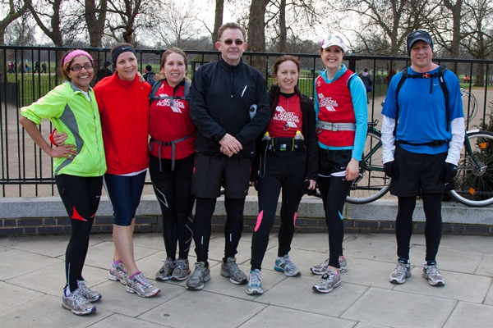
Caroline, Rachel,Sarah, Frank, Katrina, Katherine and Paul after the run.
Photo courtesy of Dave Nash -www.davenash.photoshelter.com
ENTER THE 2012 VIRGIN LONDON MARATHON. The public ballot entry system for the 2012 Virgin London Marathon will open to all applicants on Tuesday 26th April 2011. This ballot system will close when 125,000 applications have been received. Last year the ballot reached this maximum within 24 hours, so get your application in fast.
Great Marathon Runners - a new publication from Athletics Weekly!
Included are 164 pages of reviews, photos and stats - History of the marathon including the greatest big city and championship races - Features on the greatest marathon runners of our time including: Paula Radcliffe, Steve Jones, Basil Heatley, Haile Gebrselassie,Ron Hill, Grete Waitz and many more. All for only £9.99!
http://subscribeme.to/athletics-weekly/gmr#Bookazines
Charity Run opportunities. 1. ASICS British 10K London Run - 10th July 2011 - Charity is Best Beginnings - www.bestbeginnings.org.uk
2. Edinburgh Marathon, Sunday, 22 May 2011 - Bupa 10k Monday, 30 May 2011, London Run to the Beat Half Marathon on Sunday, 25 September 2011. Charity is Ndoro Children's Charities - www.ndorocc.org.uk
New for 2011 - Lactic Rush is an adrenalin pumping multi-terrain race to satisfy all you nutty off-roaders. Using natural terrain on th is vast farm land, it's the best kept secret in Essex . 10am on Sunday 15th May 2011 at Secret Nuclear Bunker, Ongar Road, Kelvedon Hatch, Essex, CM15 0LA.
This 8ish mile race will tick all the boxes, mud, watering holes, obstacles and gentle undulating fields (not). See Fixtures page on our website.
Check out the new feature on our website - RACE ENTRIES. Courtesy of an idea by Katherine Jones and the IT skills of our Webmaster Derek Wright. You can now log all the future races you have already entered or will enter, if you wish. This will allow other members to view which races are popular with our members and perhaps travel arrangements etc could be shared. Hopefully it will also help us to get some club photos pre/post event and get some good PR coverage as we'll be able to plan ahead.
Reminder. The 5k parkrun race series has now begun each Saturday morning at 9am in Valentines Park, Ilford. FREE ENTRY but you have to register in advance.< /b> www.parkrun.com
If you have a story that you would like to share with your fellow East London Runners, or should you wish to have your personal race reviews published, please contact us via the webmaster email link here:
webmaster@eastlondonrunners.org.uk

Visit our website at www.eastlondonrunners.org.uk or our Facebook page

